
Name: Rahul Kumar
Sap_ID: 500063112
Roll-No. -R100217056
Branch :- B.Tech CSE-OSOS-B2
Name of the Faculty: Dr. Durgansh Sharma Course Code: CSGG 4101
Course: Graphics and Animation Tools – Lab

Experiments -1 Installation of GIMP AND BLENDER

Installation of GIMP

Step 1: VISIT GIMP.ORG

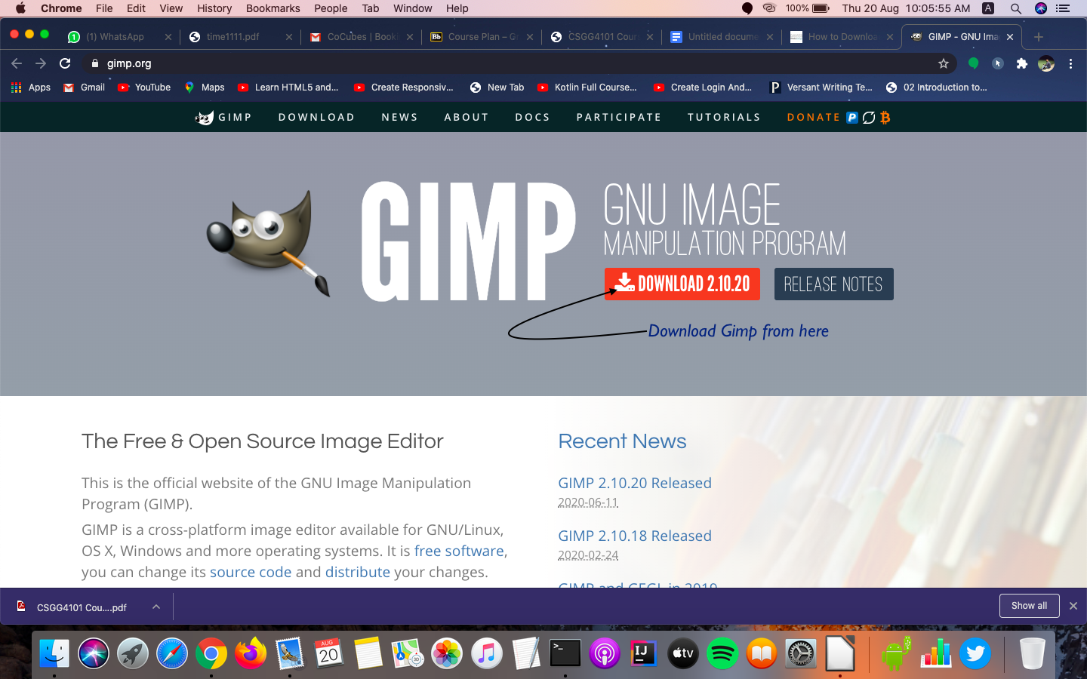
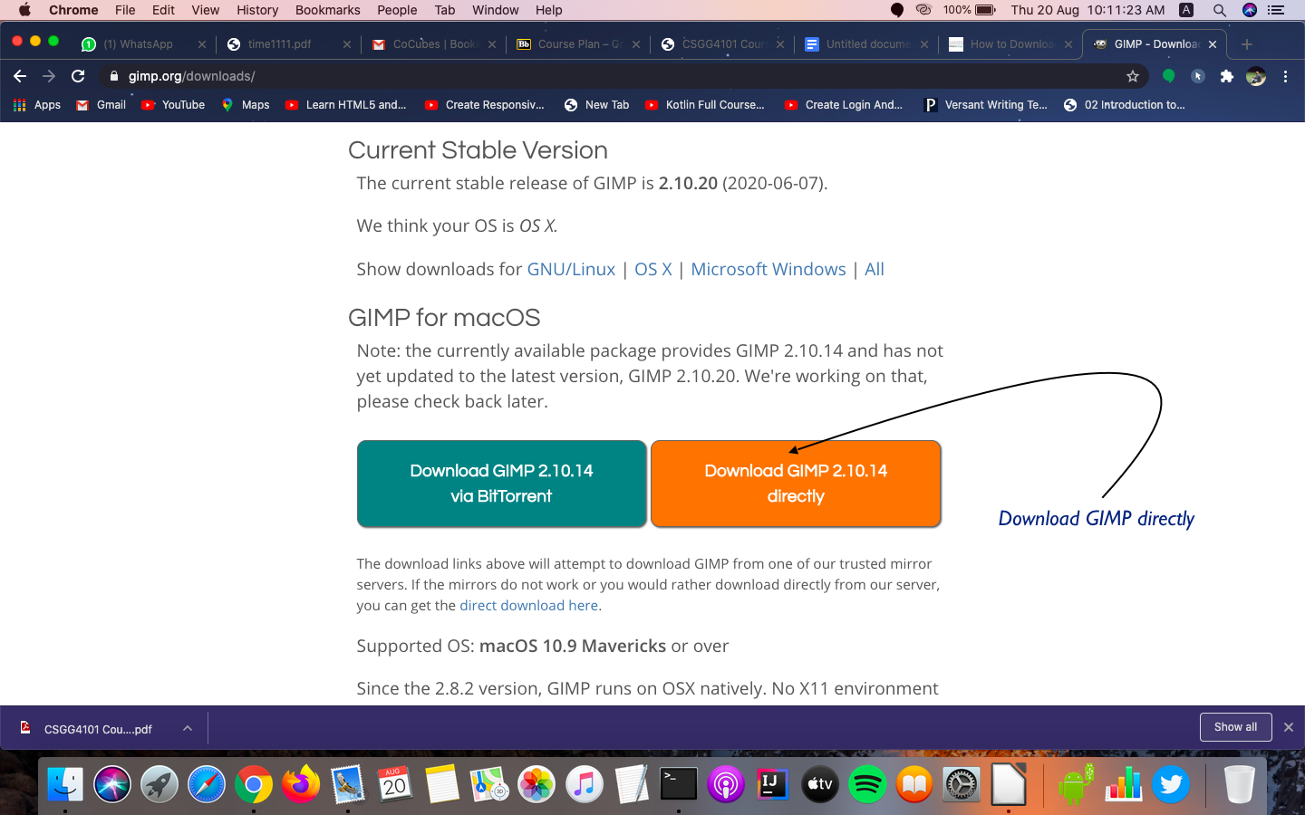
Step 2: Choose our Download

Step 3 The Gimp download package should be revealed in our downloads. It is a .dmg file, which is standard download package for mac. Click on this file once it has finished downloading.

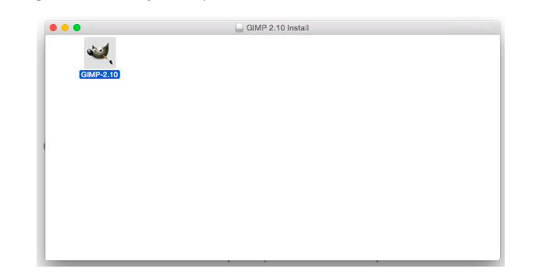
Step 4 : After this drag this icon in the application folder.

Step 5 open It :

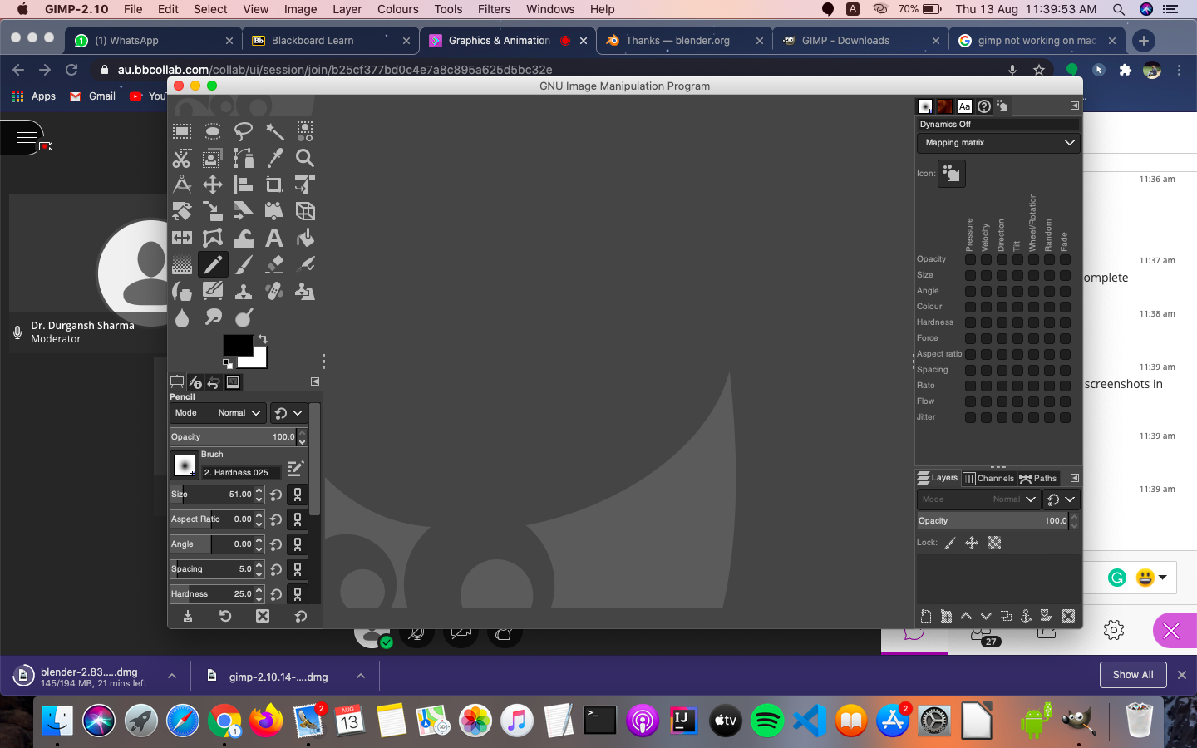

Installation of BLENDER

Step 1
download blender from link https://www.blender.org/download/

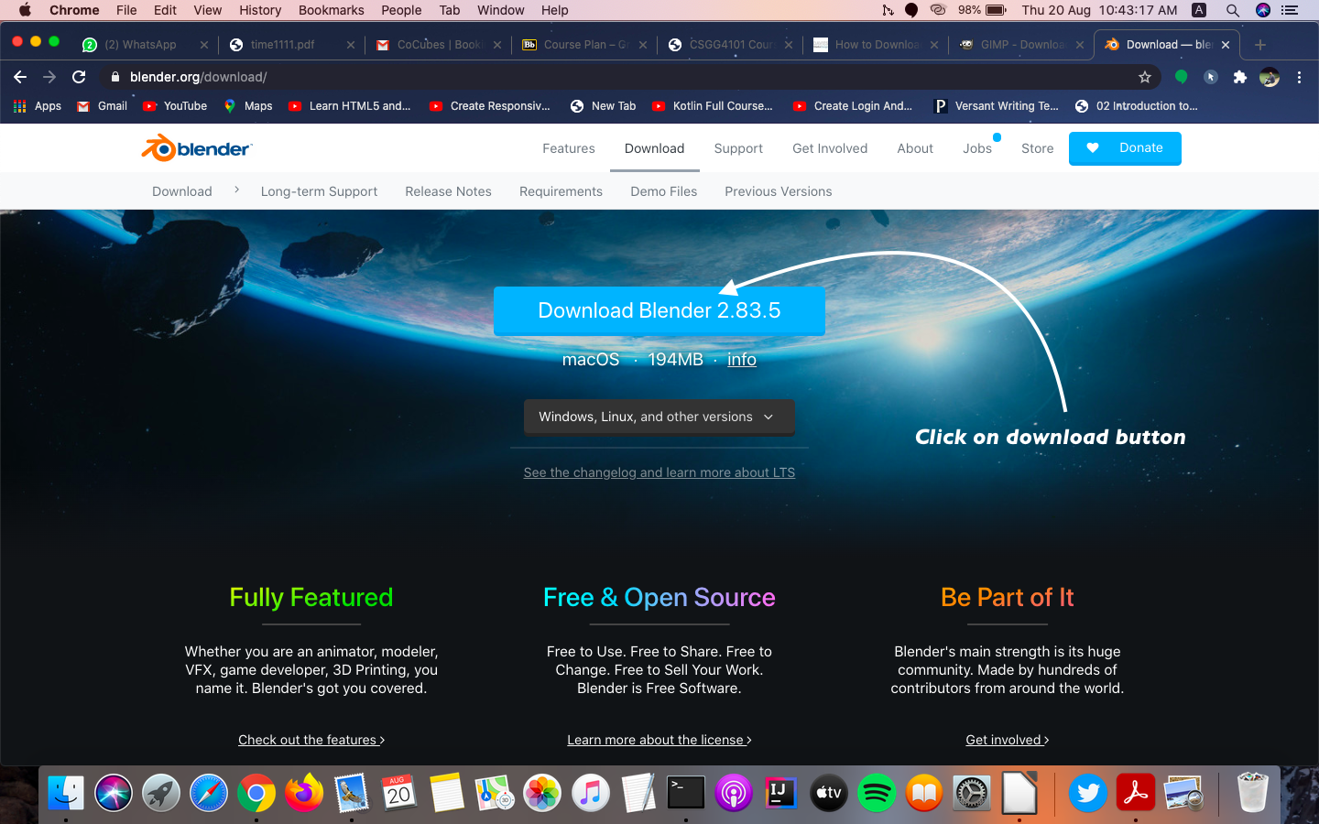
Step 2:
after download drag blender icon in application folder.

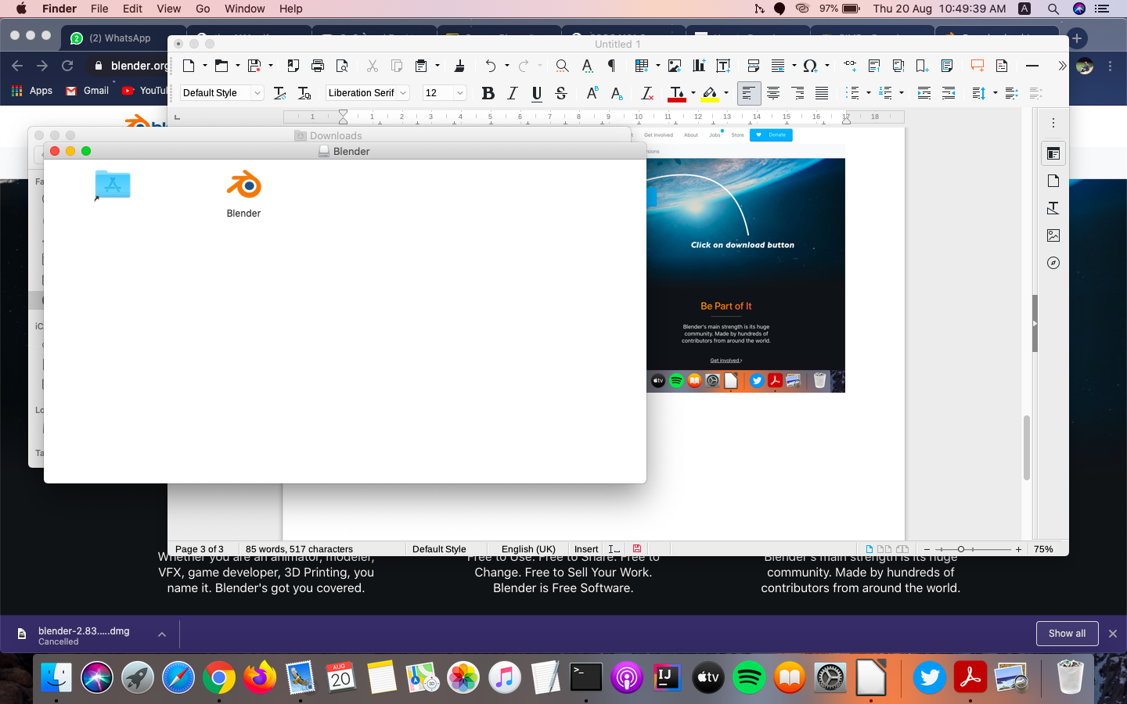

Step 3:
Now we can use Blender

